**Workshop 3 Fast transient overvoltages: lightning surges**

Date:

Name:

**3.1 Introduction**

We would like to simulate the effects of lightning strikes on a complex network. The image bellow is a scheme of a step-down power system of 35 km of length and compose of 2 power transformers. The end of this power system is in open-circuit.



**The BIL of this network is 150 kV.**

**3.2 ATPDraw implementation**

The next figure shows the ATPDraw model once it will be finalized:



Now we proceed to build the model:

1. Generator/grid



Voltage source ACSOURCE

**Three phase** voltage source.

Rated voltage: 110 kV RMS line-to-line (phase-to-phase)

Frequency: 50 Hz



Three-phase RCL3

The generator/grid (Thevenin equivalent) has a resistance of 0.803 Ohm and inductance of 25.5 mH. (Use the RLC- 3ph component)



1. Wye-Wye transformer (high voltage to medium voltage)



**Saturable three phase transformer** (SATTRAFO) settings:

**Uncheck 3-winding box**.

Coupling: wye-wye

Check RMS box.

Set primary voltage 110000 V

Set secondary voltage 23000 V

Set primary resistance of 2.56 Ohm and 218 mH

Set secondary resistance 0.1 Ohm and 8.73 mH.

Set I(0) to 0.05 A. Current through magnetizing branch at steady-state.

Set Rm to 1 mega-ohms.

Set Label: tr1

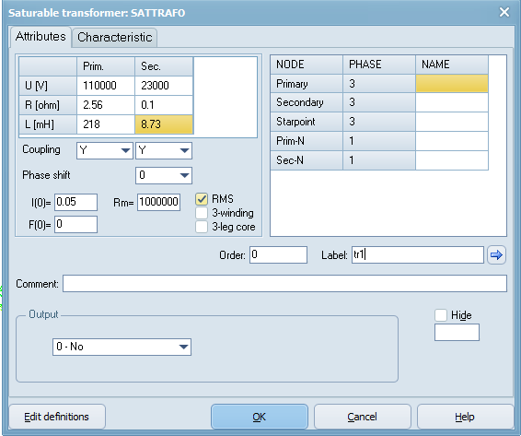

We will not set any saturation:



Finally, both neutral at each side of the transformer has to be grounded.

1. Lines



Line: LCC Template

Settings:

Set #Ph to 4 (4 wires)

Set a name: line1 (line2, line2 .. line6 for the other lines)

Check Skin effect

Check Real transf. matrix.

Set length to 20 km (10 km, 3 km and 1 km for the other lines)

Set line type: PI

check w(C) print out

Standard data as is shown bellow

Check



In Data, first you have to add **a row**

Set the geometry of the line as follow:

* Conductor radius (Rout): 0.95 cm
* Conductor DC resistance: 0.177 Ohm/km
* Three phases conductors 1(A), 2(B), 3(C) are located at the same height of 10 m. The horizontal distribution distances of the conductors are 1.75 m, 0.4m and -1.75 m.
* Regarding the shielding wire or ground wire is located at 11.65 m and centered at the tower (Horizontal =0m).
* In the case of the mid-span for the three phase conductors are assumed to be 9.5 m heights and for the shielding conductor at 11 meters.

|  |  |  |  |
| --- | --- | --- | --- |
| Phase Number | Horizontal | Vtower | Vmid |
| 1 | 1.75 | 10 | 9.5 |
| 2 | 0.4 | 10 | 9.5 |
| 3 | -1.75 | 10 | 9.5 |
| 4 | 0 | 11.65 | 11 |



Grounding of the overhead shielding wire:

The simplest model would be just a resistor but here the inductance of the ground resistance is included. The model is composed by a RL in parallel with a R:



RLC (left branch): R=13 Ohm and L=0.005 mH

R(right branch): 40 Ohm

|  |  |
| --- | --- |
|  |  |

Remember that this is single phase.

1. Load 1 (medium voltage load). Use the RLC-Y-3ph module (RLCY3). Remember that the neutral is the

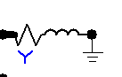

Set for each phase: R to 107.57 Ohm and inductance 616.25 mH

Name Label as: Load 1



1. Medium to low voltage transformer



Saturable three phase transformer (SATTRAFO) settings:

Uncheck 3-winding box.

Coupling: wye-wye

Check RMS box.

Set primary voltage 23000 V

Set secondary voltage 420 V

Set primary impedance 0.168 Ohm and 24 mH

Set secondary impedance 6e-5 Ohm and 0.008 mH.

Set I(0) to 0.05 A

Set Rm to 1 mega-ohms.

Set Label: TR2



We will not set any saturation:



1. Load 2 (low voltage load)



Set for each phase: R to 0.42 Ohm and inductance 4.24 mH

Name Label as: Load 2



1. Surge arrester

Branch --> Non-linear --> MOV

Reference voltage 62000 V.

Set NumPh to 3, that means that this is a three-phase arrestor.

Enable Current measurement Output.



Introduce the V-I characteristic of the MOV arrestor:



You can display (view) the introduced characteristic:



Important: If the lightning surge current is greater than the current defined in your characteristic ATP will provide an error. If this is realistic that would mean a failure of the arrestor. So, in this case we have defined up to 100 kA.

1. Lightning current source

This simulates a lightning return stroke. The current is generated by a Heidler current source and the series resistance represents the lightning channel impedance.

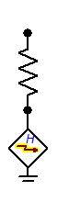

Heidler impulse current source:

Peak current 27000 A. This is the median peak current typically adopted for lightning negative return strokes.

Rise time: T_f=8e-6

tau: 20e-5

n=1

Type: current



Use a 400 Ohm serial resistance to simulate the lightning channel impedance. Enable the Current measurement as Output. A lightning channel during return stroke should have lengths of a couple of km.



**3.3 Investigation of the overvoltage performance of the network**

**3.3.1 Verify the voltages for normal operation**

As an initial point, implement a reduced model of the entire power network. After this, verify that all components are properly configured and working at steady-state and during a transient surge. You can also add the SPD to verify the correct I-V curve.

|  |  |
| --- | --- |
| Steady-state.      Voltages (phase-to-ground) in the phase A at the secondary of the transformer and load. (Here you can see the voltage drop after 20 km of line length). | Lightning strike at the end of the line (close to the load) and on the ground wire.      Overvoltages at the secondary of the transformer and load (**phaseA**-to-ground)  **After installing SPD at both line sides.**    Overvoltages goes down, around 71 kV vs 8 MV without SPD. |

Note: After verifying that the model is working, just gradually add more components and simulate them as the example above.

Place the indicated eight Voltage probes (phase-to-ground voltage probe).



Plot the voltages at:

1

2,3,4,5

6

7

8

**3.3.1 Investigate the voltages when a lightning strike at the end of the line**

Connect the lightning current source to phase A the end of the line.



Plot the voltages at:

1

2,3,4,5

6

7

8

Plot the lightning current (zoom enough to see details).

Indicate if the electrical insulation will fail among the eight measured locations.

**3.3.3 Add a surge arrester in parallel with Load 1 and investigate the voltages**

Connect the surge arrester (MOV) in parallel with load 1.



Plot the voltages at:

1

2,3,4,5

6

7

8

Plot the current at the surge arrestor (remember that current measurement has been enabled in the arrestor properties).

Indicate if the electrical insulation will fail among the eight measured locations.

**3.3.4 Add more surge arresters to avoid the failure of the electrical insulation**

Now distribute the surge arrestors in order to avoid a failure of the electrical insulation in all the network. If you need arrestors for the grid side or at the low voltage side (eg. at probe 8), search on the internet for characteristics of these arrestors.

Plot the voltages at:

1

2,3,4,5

6

7

8

Discuss the results.